Name: | ___________________________________________________ | Date: ___________
 | Year 10 Mathematics Exam  Test 4 - Measurement | 50  = %
Weighting | 5% of Total Grade | 60 minutes
Resources allowed for Section 2 | Applications Formula Sheet, 1 Page hand written notes (unfolded), Scientific calculator, Approved Stationery

Q1) Find the area of the composite shapes below.
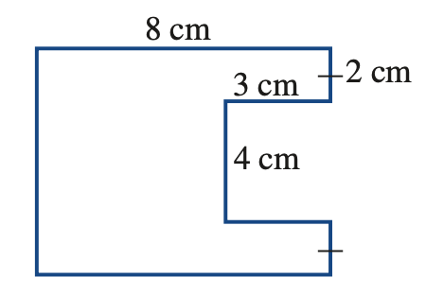

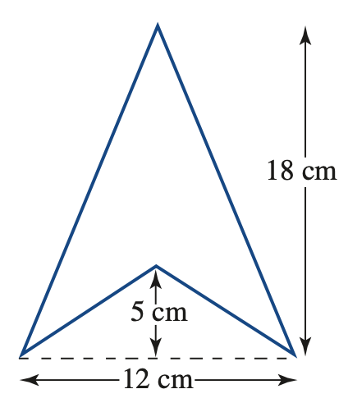

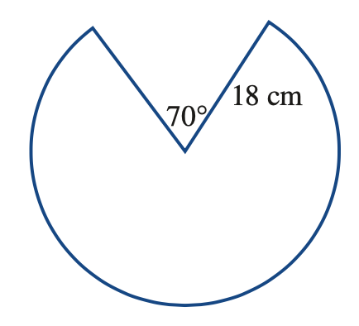

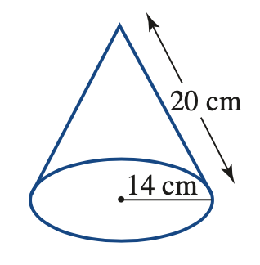
Q2) Determine the Surface area of the following Shapes
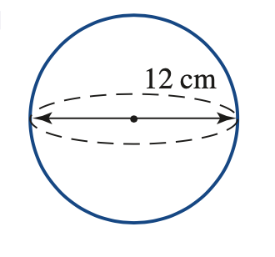

Q3) A Farmer orders three new silos, of dimensions listed below. They need to be treated externally with an anti-rust paint.
- Determine the total surface area of the metal to be coated with an anti-rust treatment.

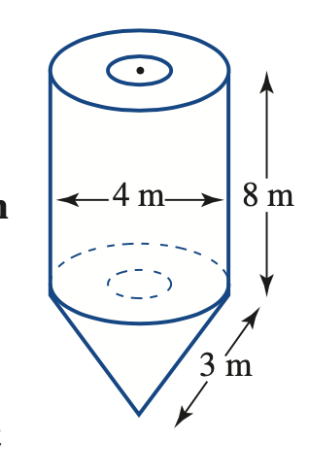

- If the anti rust paint cost $12.50 per m2, how much for all three silos to be coated?

Q4) Determine the Volume of the following shapes

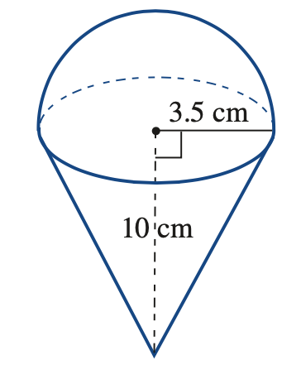

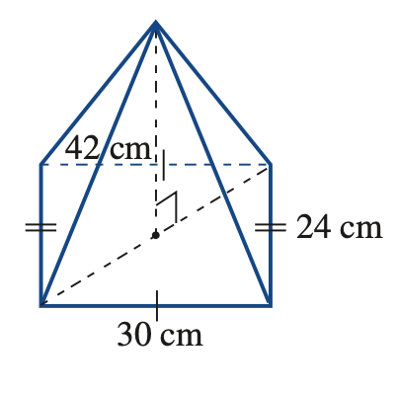

Q5) A cube has a volume of 91125cm3. Determine the Surface area of this cube.

Q6) Tennis balls are 8cm in diameter, and shipped in tubes of three, arranged in a 4x5 pattern.

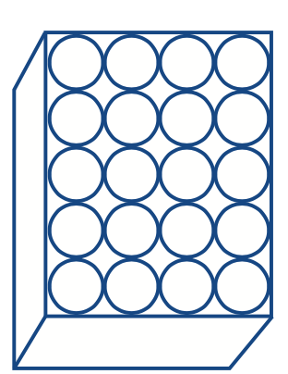
- Determine the total volume of tennis balls if they were to be arranged as shown below

- Both the tubes and packing boxes are designed to have as little wastage as possible. Determine the minimum dimensions for the height, width and depth of the box, and hence, find the total volume of the box

- The remaining space is filled with packing peanuts. If each peanut has a volume of 13cm³, how many peanuts would be in each box? (round to the nearest whole peanut)

